Task:

Check whether the Base OS, VM’s can be remote accessed from other PC, mobile using SSH, VNC

1. In base machine install tigervnc-server
2 Create a user vnc user and set password also.
3.Copy vncserver@.service from /usr/lib/systemd/system/ to /etc/systemd/system with port number need to connect to vncserver.
cp /usr/lib/systemd/system/vncserver@.service /etc/systemd/system/ vncserver@:3.service
4. vim /etc/systemd/system/ vncserver@:3.service
In that file line number 40,41 replace <user> to vncuser
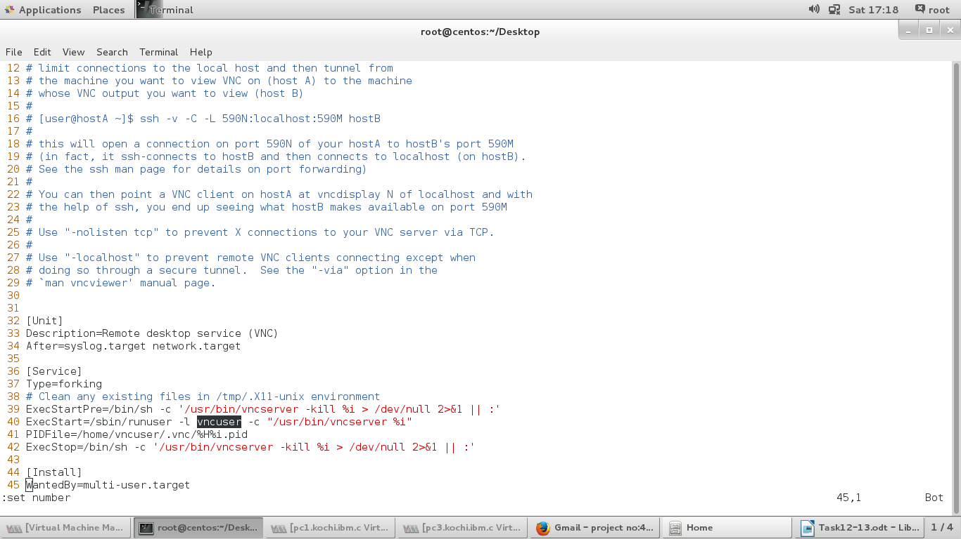
5. systemctl daemon-reload
6. Switch to vncuser and set vncpasswd
7. Start and enable vncserver@:3. service
8. Add vnc-server service in firewall
9. In pc3 install tigervnc
10. From pc3 base machine accessed as below.

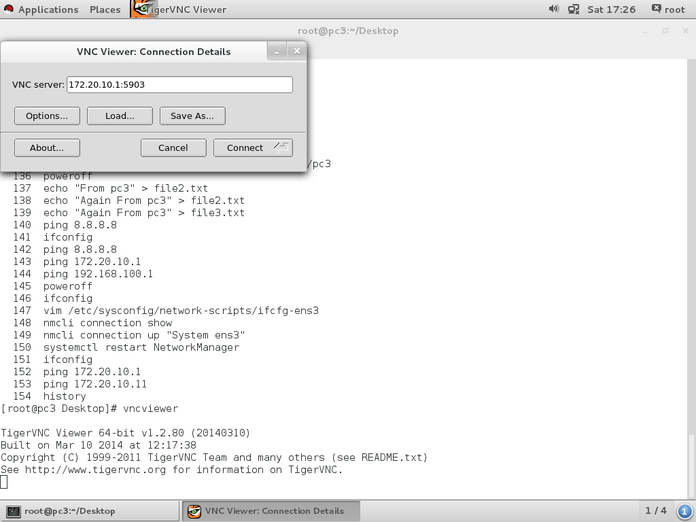
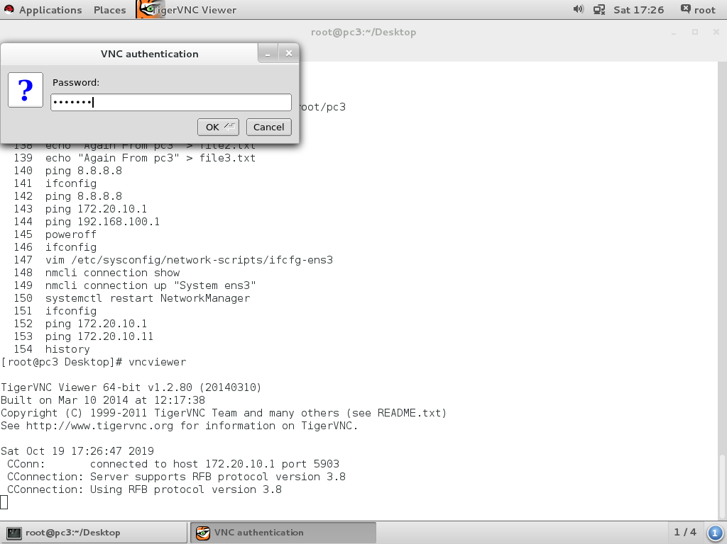

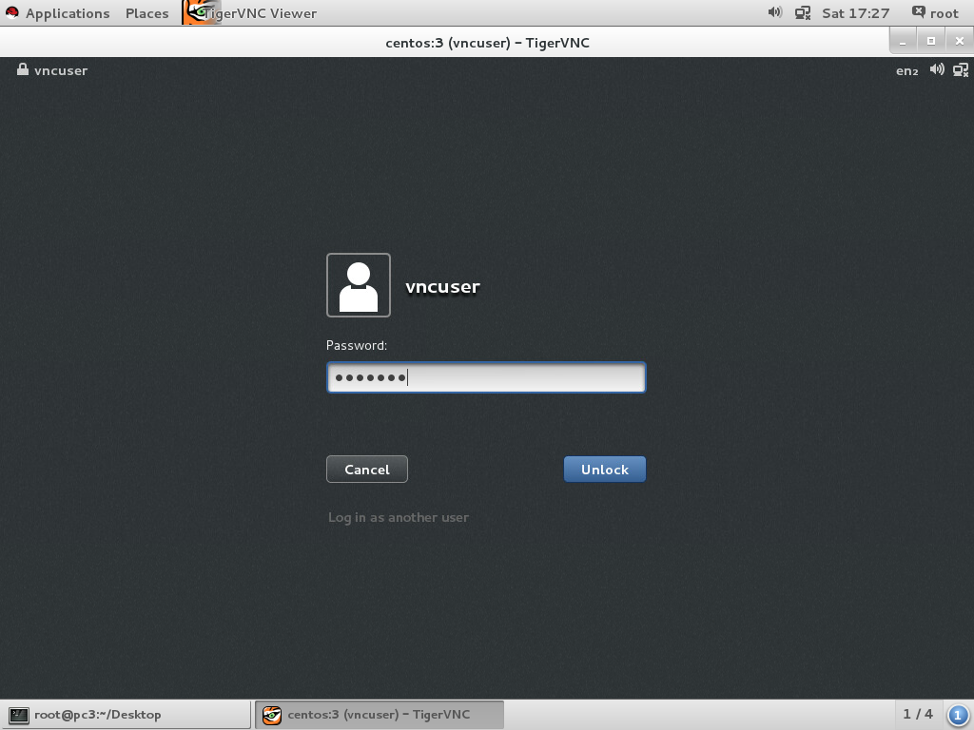
Task 11. From mobile vncserver accessing using VNV Viewer app
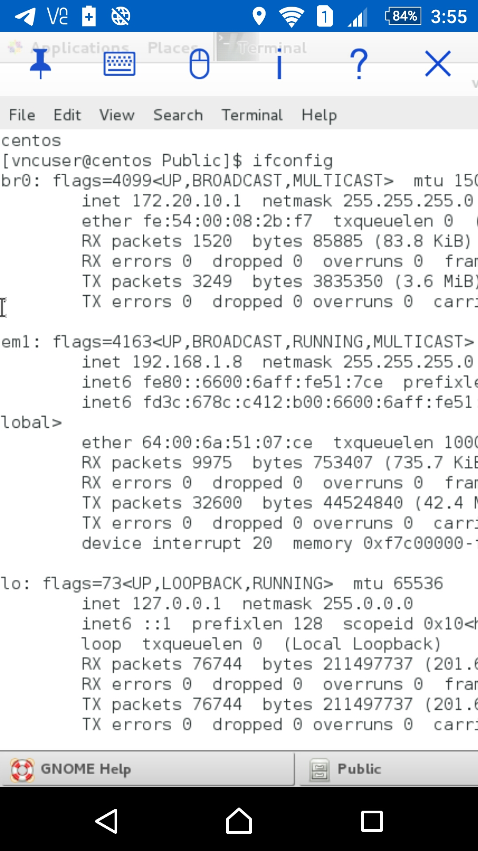
Task 12: From mobile base machine ssh using JuiceSSH aap
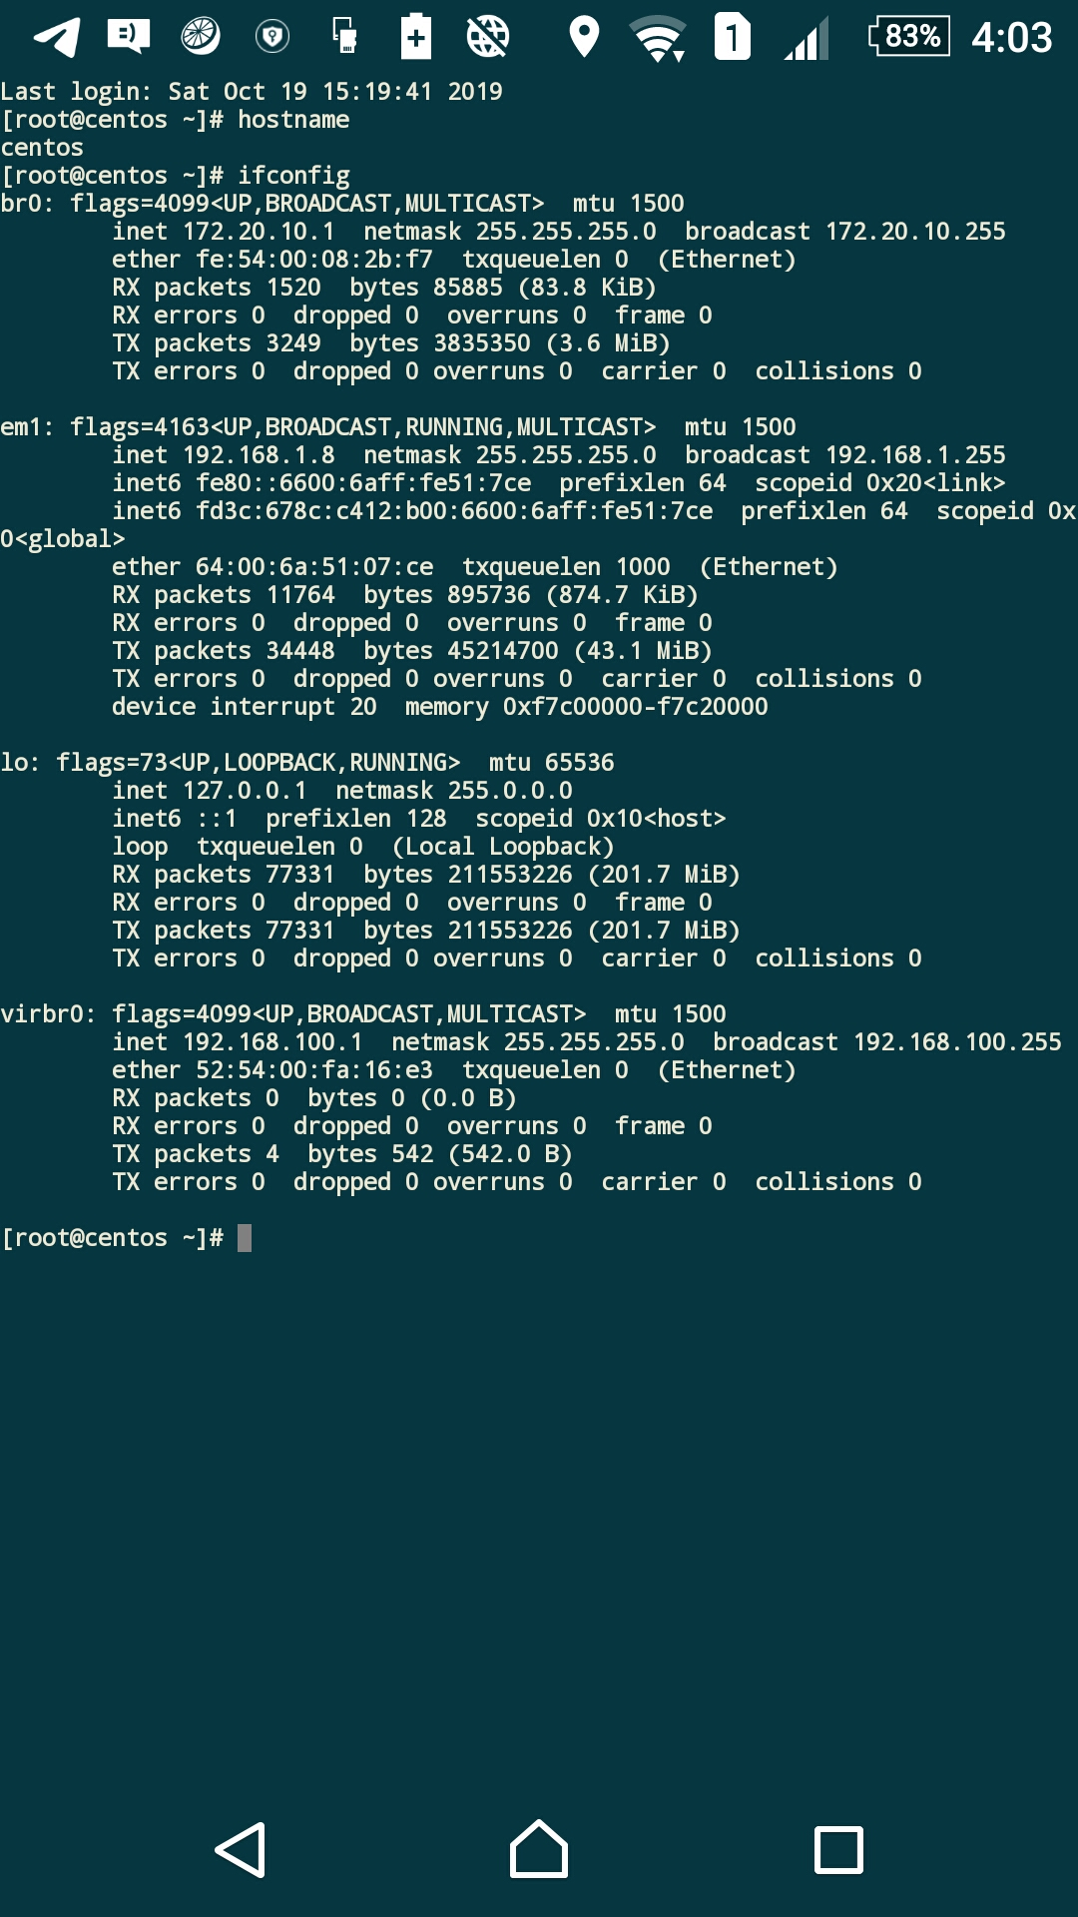

Task 13:
Configure PC1 as Web Server and File Server
Share File’s using File Server and check whether from client you are able to upload and download files
For FTP
Configure vsftpd/ sftp → Jailed if possible
Access via FileZilla
For Web server
Configure apache
→ Access using browser

1. vsdtpd package installed in pc1.
yum install vsftpd
2. Configure vsftpd.conf file as below
vim /etc/vsftpd/vsftpd.conf

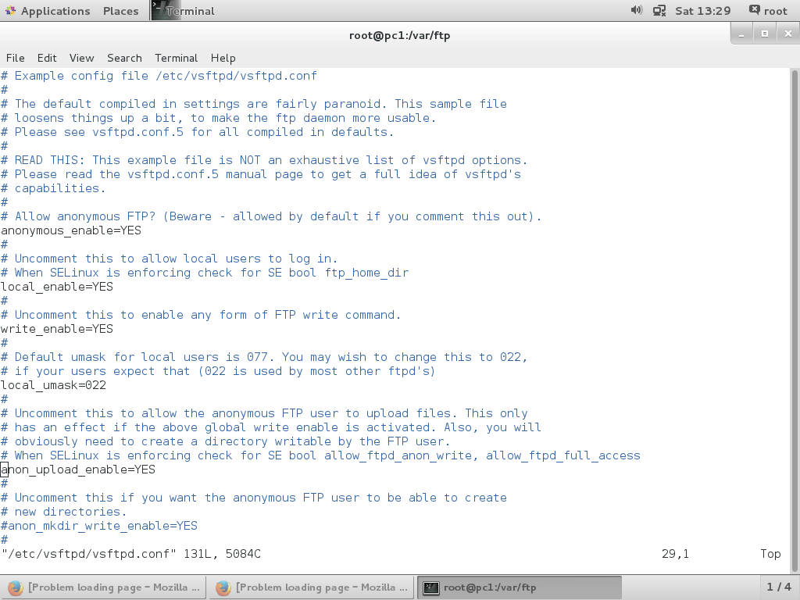
3. Turn on following seboolean
setsebool -P ftpd_anon_write on
setsebool -P ftpd_full_access on

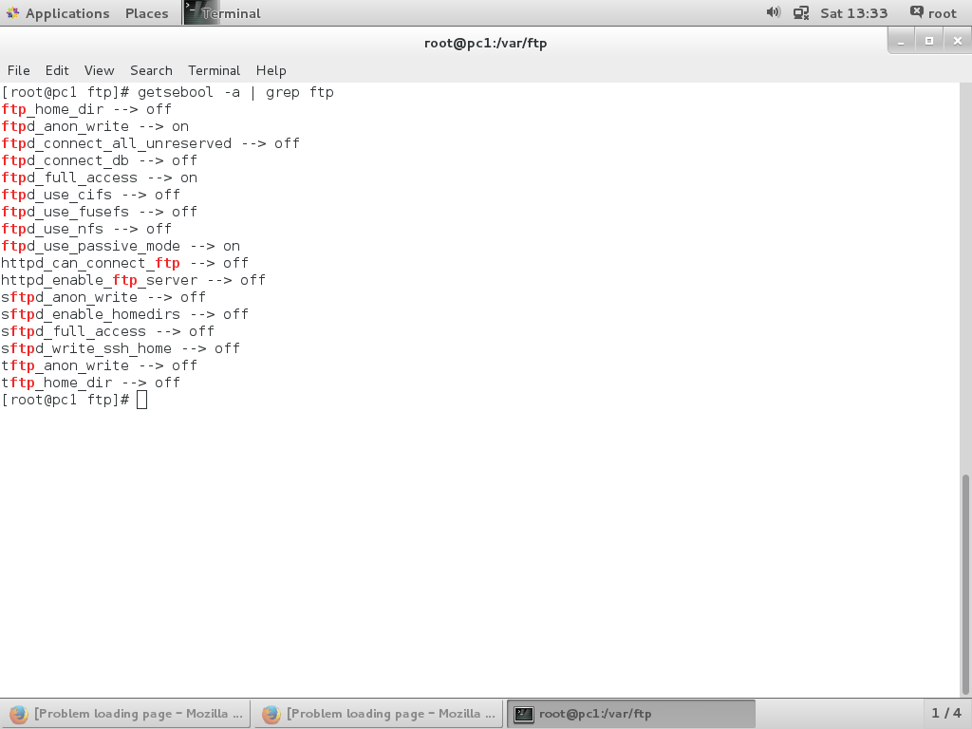
4. Created directory data inside /var/ftp/
mkdir /var/ftp/data
5. Change ownership of above directory to ftp.
Chown ftp:ftp /var/ftp/data
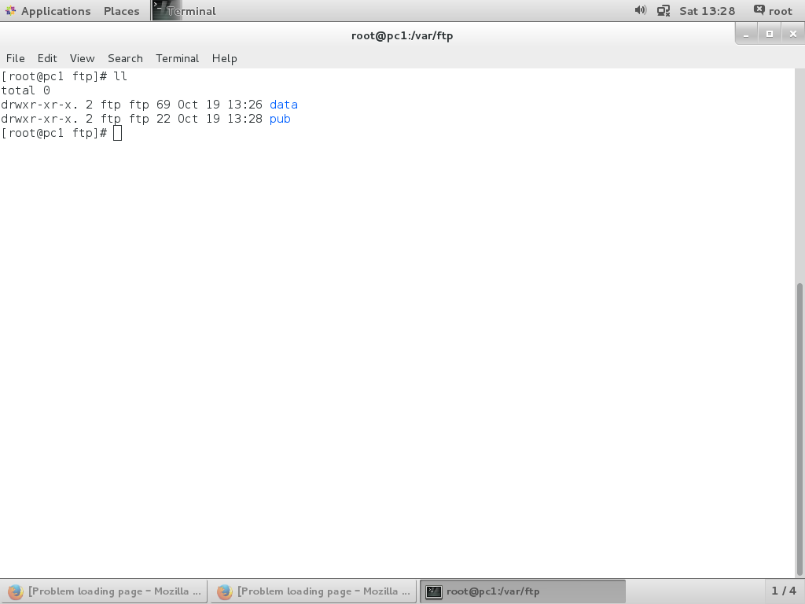
6. Added service ftp in firewall
firewall-cmd –permanent –add-service=ftp
firewall-cmd –reload
7. Start and enable vsftpd service
systemctl start vsftpd
systemctl enable vsftpd
8. ftp client installed in pc3
yum install ftp
9. Screenshots regarding uploading and downloading files from pc3 is given below.

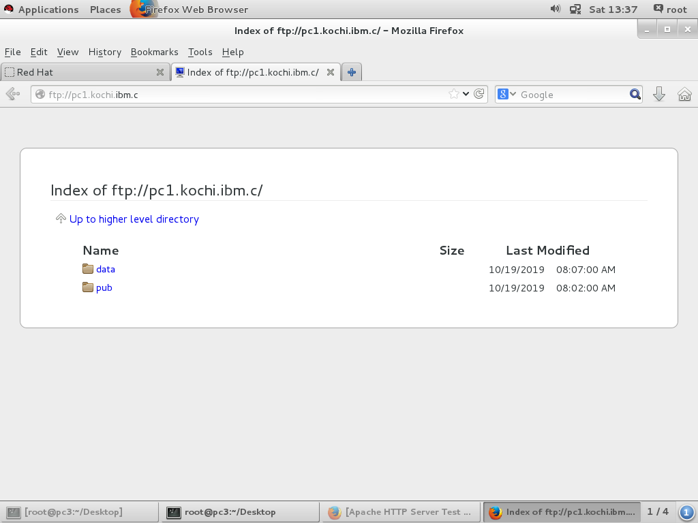

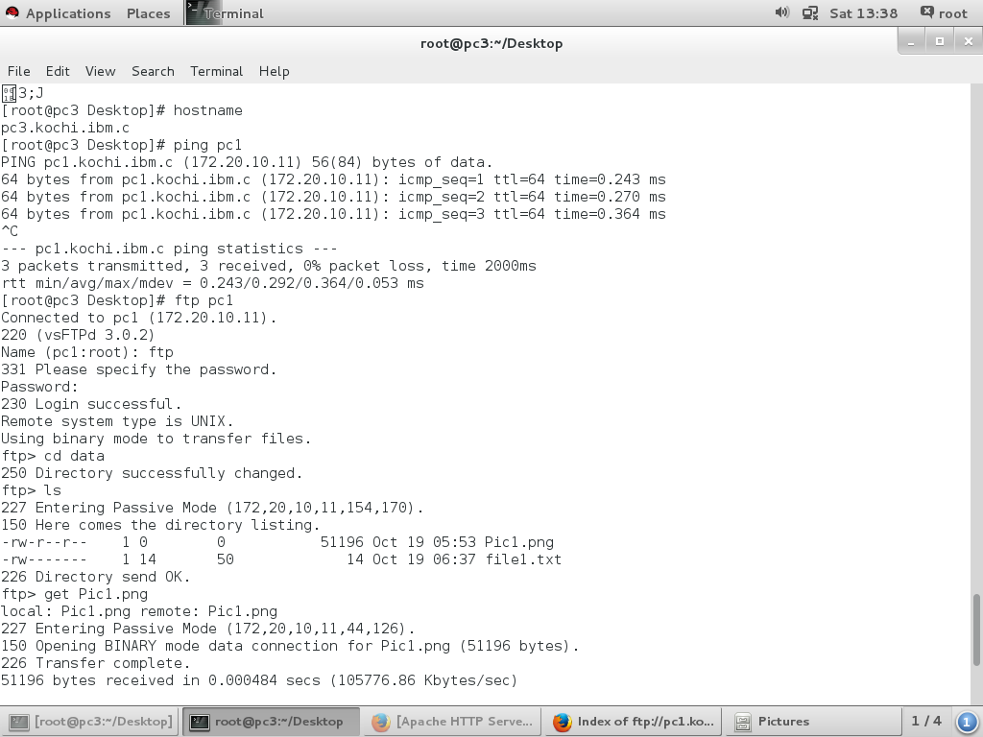
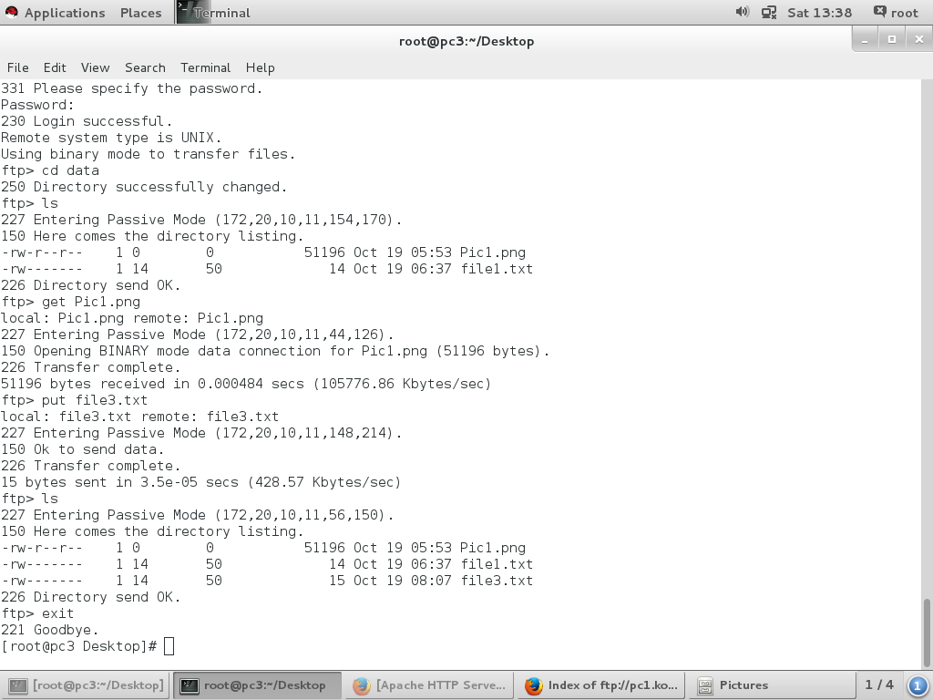

Web server configuration

1. Install httpd package
yum install httpd
2. Create an html web page in /var/www/virtual/index.html
3. Create a configuration file /etc/httpd/conf.d/www.conf
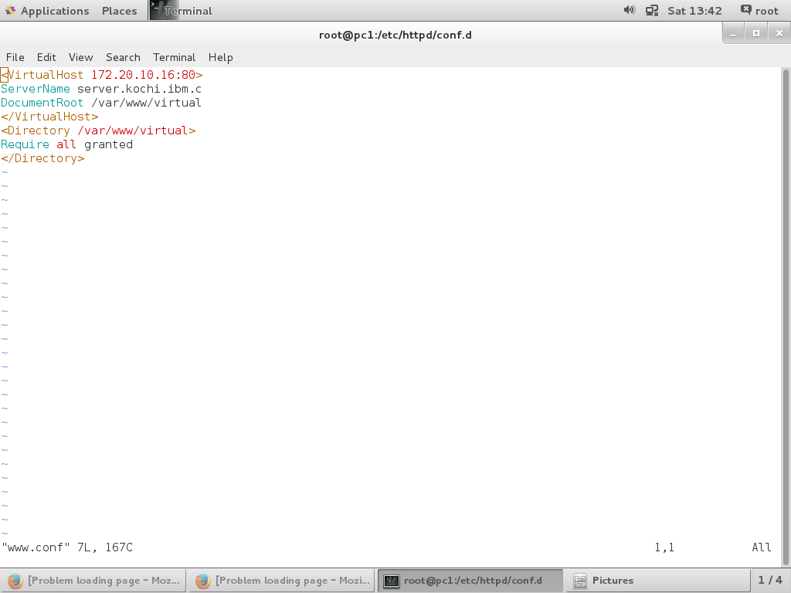
4. Add ip 172.20.10.16 in pc1
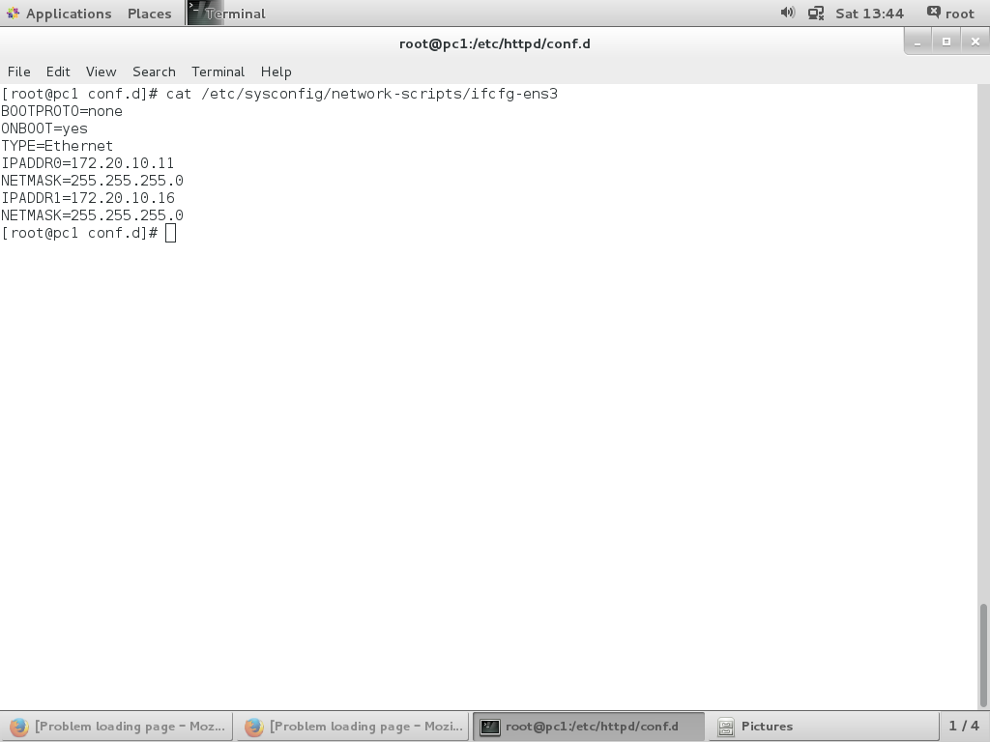
5. Start and enable httpd service
6. Add http service in firewall
7.Add host server.kochi.ibm.c with ip 172.20.10.16 in DNS configuration file in pc3. And restart named service.
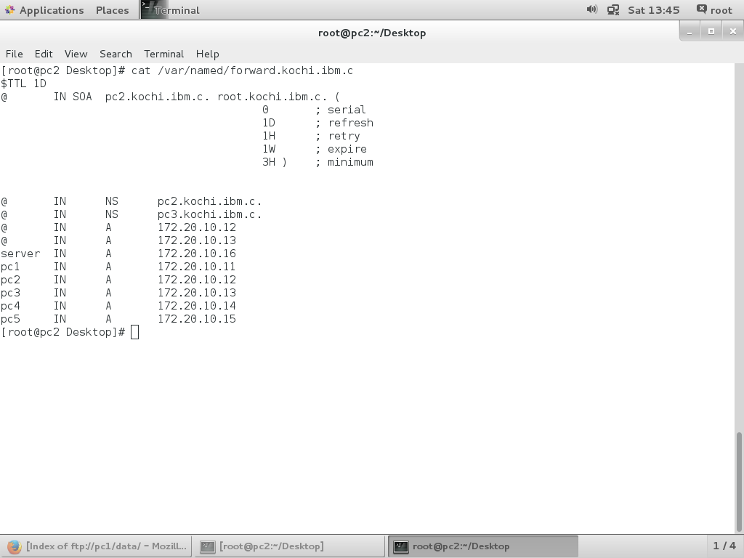
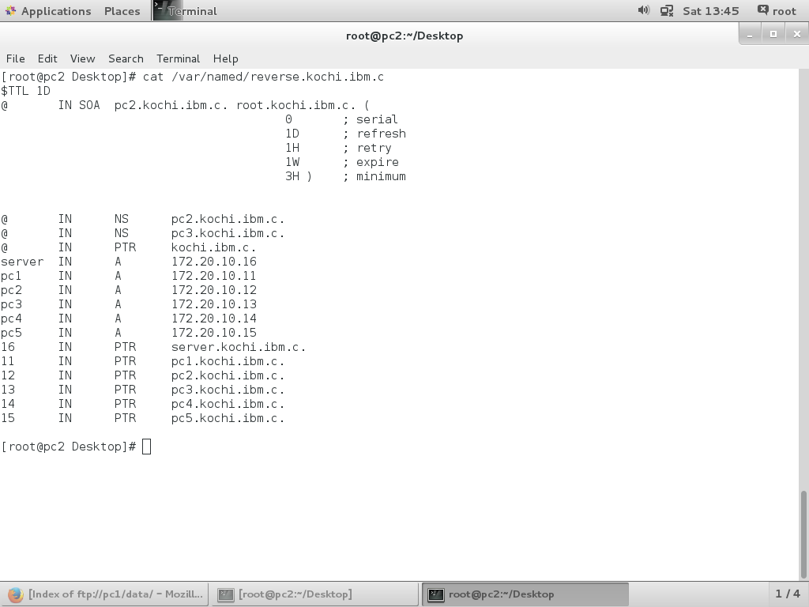
8. Accessing website server.kochi.ibm.c from pc5

